Networking Subscriber Design Document

Security Classification: | Internal
Status: | Issued
Version: | 1.0
Team/Department : | Core Development\Networking
Author: | Robert Lundie
Approver(s): | Networking TA | Distribution: | Internal only

Contents

1 Introduction 3
1.1 Purpose and Scope 3
2 Design Overview 4
2.1 Design goals 4
2.2 Solution 4
2.3 Message identification 5
2.4 Example 6
2.4.1 Basic use 6
2.4.2 Component Migration 6
2.4.3 Interface consolidation 7
2.4.4 Component Migration 7
2.5 Interface 8
2.5.1 Environment 8
2.5.2 Create NetSubscribe object 8
2.5.3 Create handlers 8
2.5.4 Expressing interest 8
2.5.5 Catching events 8
2.5.6 Expressing disinterest 8
2.5.7 Delete NetSubscribe object 9
3 Detailed Design 10
3.1 Overview 10
3.2 Specialisations 10
3.3 Class Diagram 10
3.4 Class Overview 11
3.4.1 CNetSubscribe 11
3.4.1.1 Member data 11
3.4.1.2 Member methods of note 11
3.4.2 XSignal 11
3.4.2.1 Member data 12
3.4.2.2 Member methods of note 12
3.4.3 TEvent 12
3.4.3.1 Member data 12
3.4.3.2 Member methods of note 12
3.4.4 TEventClientData 13
3.4.4.1 Member data 13
3.4.4.2 Member methods of note 13
3.4.5 TEventDataArray 13
3.4.5.1 Member data 13
3.4.5.2 Member methods of note 13
3.4.6 CSignalActive 13
3.4.6.1 Member methods of note 13
3.4.7 CPSSignal 14
3.4.7.1 Member data 14
3.4.7.2 Member methods of note 14
3.4.8 CPSSubscribe 14
3.4.8.1 Member methods of note 14
3.5 Build details 14
4 Further Information 15
4.1 References 15
4.2 Open Issues 15
4.3 Glossary 15
4.4 Document History 15

Introduction

Purpose and Scope
This document describes the design of a helper library (“Net Subscribe”) to manage the receiving of messages from arbitrary sources, signalled in arbitrary ways, over arbitrary transports, through a single interface.
Net Subscribe would be of use to any component which requires handling of messages, as it removes the need to repeatedly reimplement the functionality to transport the events. The functionality to transport the events would be implemented once (in Net Subscribe), and accessed through the Net Subscribe interface, where the exact transport type can be referred to by enumerated type.
Net Subscribe is being developed in conjunction with other components for the DHCPv6 project [R1].
The intended audience is developers and maintainers who wish to gain knowledge and understanding of these components.

Design Overview

Design goals
- To give the developer more time to focus on their functionality rather than how they are transporting messages back and forth
- To ease the migration between messaging mechanisms (for example when a component needs to be moved into a different thread / process)
- To minimise memory usage and code redundancy
There are numerous ways in which data can be passed between components in Symbian OS. One example is message queues; another example is publish/subscribe buffers. The receiver of such events (we’ll refer to this as the client) has to have a specific implementation depending on which mechanism is to be used.
If we had a way for the client to just supply an event handler that received data of the desired type, and somehow register with the system to receive its desired events, it would decouple the design of the component from the messaging mechanism used, and so would achieve the above aims.

Solution
Net Subscribe will provide:
- an interface with which to define message transports for arbitrary transport layers (e.g. pub/sub buffer, message queue), and an example implementation (pub/sub buffer)
- an interface with which to define signal handlers for different signal types (e.g. Active Object, request status), and an example of its use (pub/sub over active objects)
- an interface with which to define event handlers for arbitrary types of message data (e.g. SMetaData*, TInt, TBufC), and an example of its use (SMetaData*)
- automatic repeat registration for events (a “subscription”-like behaviour)
- a client class through which to perform registration and cleanup of multiple event handlers

A request to NetSubscribe to perform subscription to an event would only ever need to contain:
- Data transport mechanism (enumerated)
- The identifier of the signal raised when the event occurs
- Reference to event handler callback
- Reference to error handler callback (optional)
- Client data (for context- the “this” of the callbacks)

After that point, if there were ever a need to use a different messaging mechanism for the same event, it would only require a change to enumerated value of the data transport mechanism. This is a great advantage over having to reimplement the client side of the messaging mechanism every place it is used.

Message identification
The structure SSignalId will be used to identify a specific message:
TUint32 iEventImplementation the message class (e.g. “IP events”)
TUint32 iEventId the message type (e.g. “IP event: M flag received”)
TUint32 iHandle the context (e.g. “for Ethernet interface 1”)
The message class (iEventImplementation) and type (iEventId) are predefined enumerations, but the context (iHandle) is a value that must be determined in a way specific to the class and type.
For example, for IP events, the context must be found by asking the IP event notifier to send it event messages for a named interface, for which it receives back the handle value.
For other message classes, different information would be required to set up the communication. This is why this step won’t be built into the base NetSubscribe interface (it may be added to specific transport implementations if appropriate).
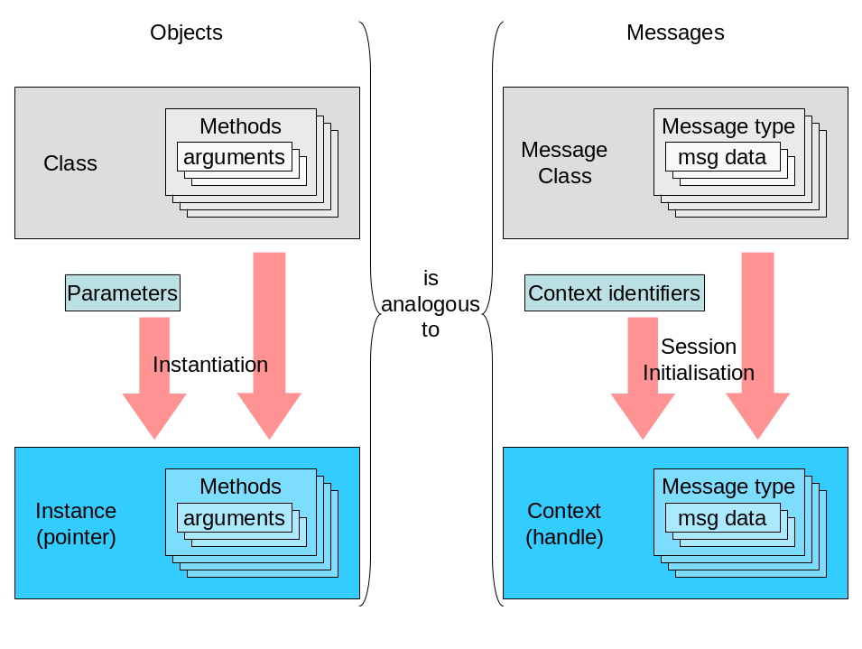

Example

Basic use
In this case the use of NetSubscribe appears to be an excessive layer of abstraction. However, having implemented it like this, the server can change its messaging transport with minimal changes to the client (a change to the transport type enumeration, and change to the way the session is started, but no changes to the way messages are handled):
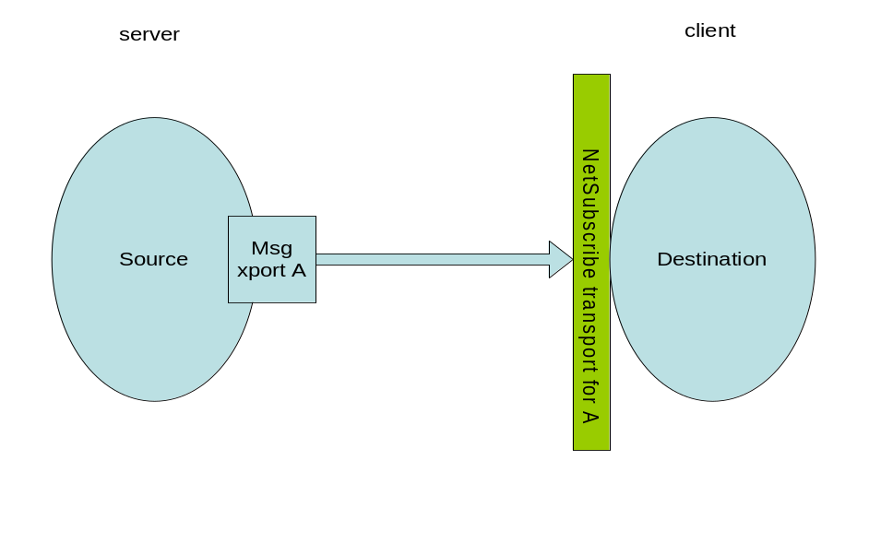

Component Migration
Even if the change to the server was more elaborate (e.g. if it moved to a different process), adding a simple component in the server process to forward messages (e.g. to message queue), and a handler on the client side (i.e. a NetSubscribe transport to receive from a message queue, assuming it wasn’t already implemented) would be the only things required to ensure the client could still receive its messages (rather than changing the server’s implementation to raise messages differently):
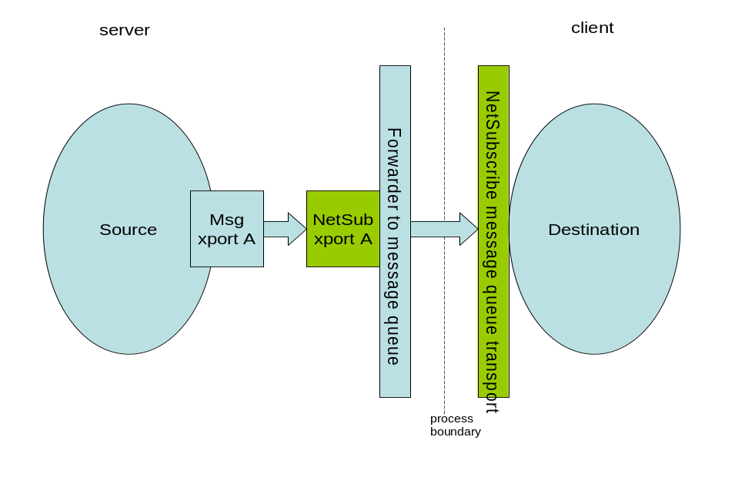

Interface consolidation
Building on this, the following diagram shows how a variety of heterogeneous interfaces could be dealt with in a uniform way to simplify a client’s implementation. Say there are various notifications / messages which a client needs to receive from another process. A NetSubscribe specialisation would be needed for each of the interfaces’ transports, all of which would be handled in a single place, and forwarded on to the message queue:
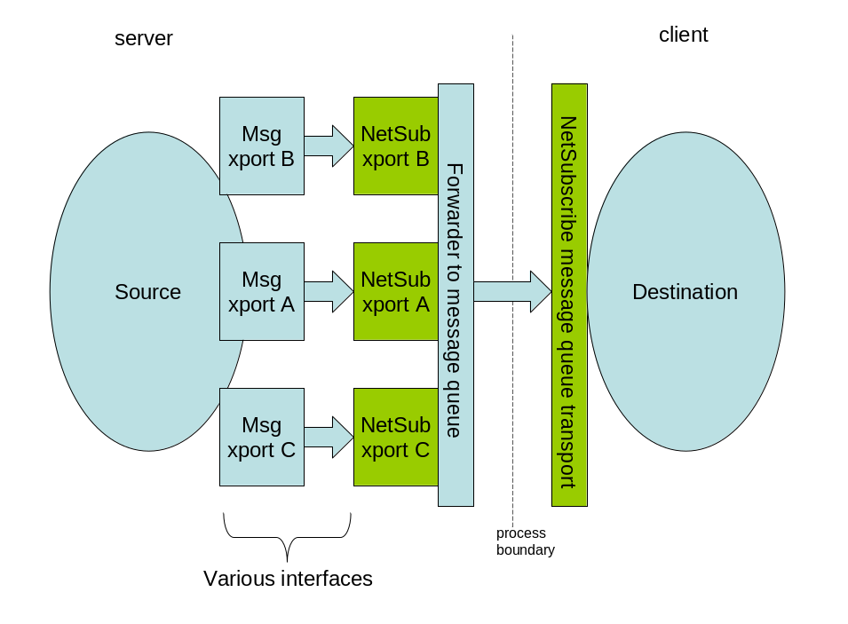

Component Migration
If ever this configuration changed in terms of where the client lived, e.g. if the process boundary became a platform boundary and the messages were forwarded across the network, the client would only need small changes to some enumerated parameters to use a different NetSubscribe receiver.
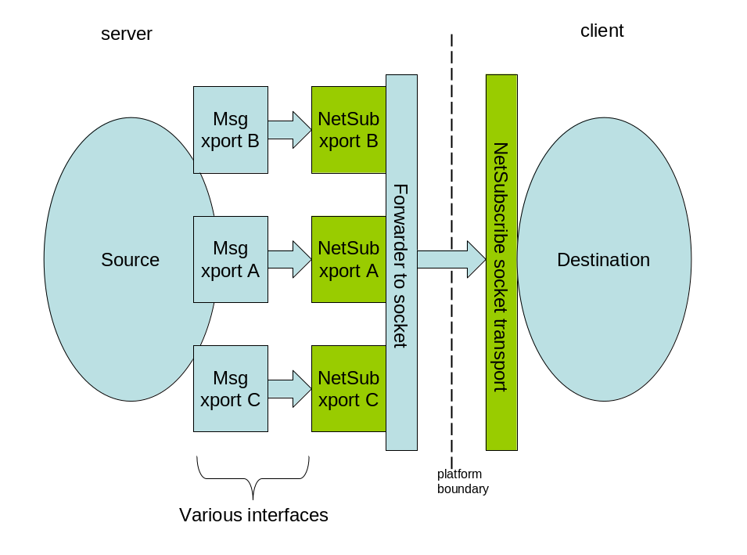

Interface

Environment
A client will access the NetSubscribe functionality through a single instance of a CNetSubscribe object.
The prototypes will be declared in the header “netsubscribe.h”.
The NetSubscribe functionality will be built as a dynamic library, “netsubscribe.dll”. It will be one of the “Elements” in comms-infras.

Create NetSubscribe object
Create an instance of the subscription client class, CNetSubscribe. This instance will be able to keep track of many event handlers for a given transport type, which must be specified on creation (pub/sub is used in this case):
STypeId typeId(KTransportUid, EPublishSubscribe);
CNetSubscribe * netSub = NetSubscribe::CNetSubscribe::NewL( typeId );

Create handlers
Create a static handler function with the following signature.
static void CSomeClass::EventHandler(TAny* aClientData, const Meta::SMetaData* aRcvdData);
The client data is anything you need access to when a subscription event is being handled- for example, it could be a structure containing flags to be set, or perhaps methods to notify other parts of your application about the event.
Note the received data argument in this case can vary in type, depending on the type of the event being received. SMetaData [R2] is a self-described object with versioning and serialisation functionality, so is a good base class for messages (which e.g. may need to be forwarded through other buffers by type-agnostic code).
Create a static error handler function (for when message transport fails) with the following signature.
static void CSomeClass::EventErrorHandler(TAny* aClientData, TInt aErrorCode);
Then package this all up into a TEvent object:
TEvent event (iSomeClassInstance, CSomeClass::EventHandler, CSomeClass::EventErrorHandler);

Expressing interest
The source for the signal denoting the message’s occurrence will be identified with an SSignalId. The value aHandle will have to be predetermined between the client and the entity raising the events, by telling the server (in a way specific to the transport being used) to initiate a session.
SSignalId signalId( aEventImplementationUid, aEventId, aHandle );
Register the event with CNetSubscribe by calling its SubscribeL method:
event->SubscribeL(*netSub, signalId);

Catching events
Keep the CNetSubscribe instance for as long as you require subscription tracking. While the Active Scheduler of your process is running, Net Subscribe will pass on event notifications to the appropriate handler(s).

Expressing disinterest
If required later, you can stop receiving the specified event like so:
event->Cancel(netSub);
.. or if you don't want to have to keep track of the individual events you used to subscribe, simply delete the CNetSubscribe object, and it will cancel and clean up all the event handlers.

Delete NetSubscribe object
When the CNetSubscribe object is deleted, it will cancel and delete all its event handlers, so you would no longer receive any of the previously registered events.

Detailed Design

Overview
The Net Subscribe component presents an interface to the client, CNetSubscribe.
A client must keep an instance of this class for each signal/transport method its events are using.
CNetSubscribe keeps track of active event subscriptions by having a vector of owned XSignal objects. Each XSignal object monitors one signal, and dispatches it to all event handlers that are interested in that signal.

Specialisations
An example implementation will be provided, representing the capability to receive notifications of publish/subscribe property changes. This will exist as the derived classes CPSSubscribe, CPSSignal. It will be based upon the CSignalActive class (which catches signals via the active object framework).

Class Diagram
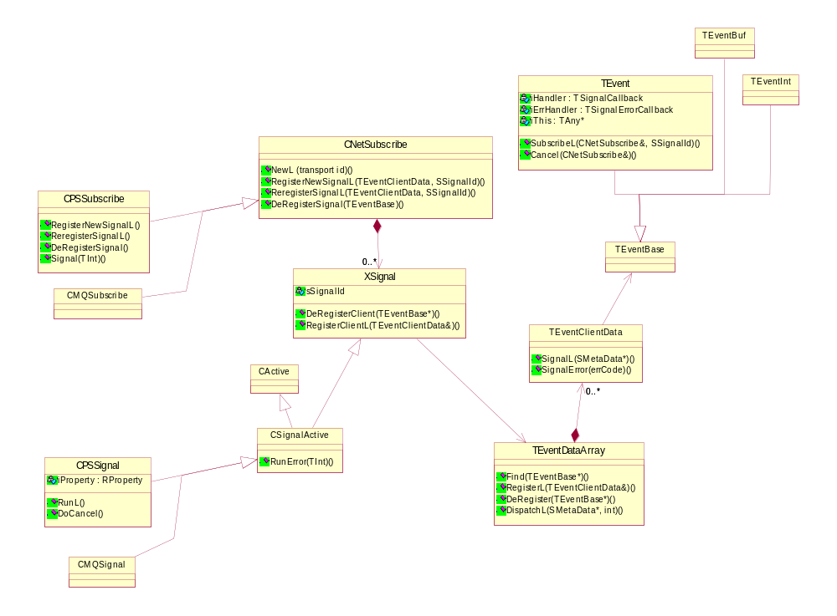
Figure 1: Class Diagram

Class Overview

CNetSubscribe
This class abstracts the mechanism the signals are registered, trapped and the way event data is marhalled/demarshalled.
It must be derived from to manage specific signal sources & transport layers
It allows for multiple signals to be registered and tracked.

Member data
RPointerArray<XSignal> iSignals;
This contains pointers to the individual signal objects (which can be individually added/removed using the RegisterNewSignalL and DeRegisterSignal methods)

Member methods of note
public: IMPORT_C ~CNetSubscribe();
This ensures that all signal objects are deleted individually.

public: IMPORT_C static CNetSubscribe* NewL( const Meta::STypeId& aTransportId );
protected: explicit CNetSubscribe();
A CNetSubscribe instance should only be created with its NewL method, which takes a TypeId specifying the transport/signalling method to use. With this it acts as a factory to instantiate the appropriate CNetSubscribe-derived class.

protected: void RegisterSignalL(TEventClientData& aData, const SSignalId& aSignalId );
This looks for an already registered signal with the specified SSignalId, if found it adds the specified Event handler aData to its list of dispatches.
If not, it just calls RegisterNewSignalL with the same parameters.
protected: virtual void RegisterNewSignalL(
TEventClientData& aData, const SSignalId& aSignalId )=0;
This is to be implemented in specific implementations. Its job is to register for the specified signal, and create a signal handler (XSignal instance) to catch it (which it keeps in its iSignals array).

protected: void DeRegisterSignal(TEventBase* aEvent);
This simply searches iSignals for any XSignals that are dispatching to the specified event, and it removes those associations. If no handlers are left for a given XSignal, it will delete that XSignal (unregistering for further occurrences of that signal).

XSignal
This class is the interface which abstracts the physical signal source (active object, status request, etc..)
The class is owned by CNetSubscribe and represents a signal that can have multiple client handlers registered.
Derived classes are expect to handle specific types of signal and call Dispatch on the iData member, to get the message that the event has occurred through to the event handlers.

Member data
protected: const SSignalId iSignalId;
The identifier of the signal (see 2.3)
protected: TEventDataArray iData;
This contains by value a smart array object which can contain multiple event handlers for the signal.

Member methods of note
public: TInt RegisterClientL( TEventClientData& aData )
Registers the specified event handler against this signal. Returns the number of event handlers for the signal after the add.
public: TInt DeRegisterClient(TEventBase* aEvent)
Deregisters the specified event handler. Returns the number of remaining event handlers for the signal.

TEvent
An event class to convey callback info and callback data of type SMetaData. Derived from TEventBase. Similar implementations can be derived from TEventBase for other data types.

Member data
protected: TAny* iThis;
The context of the messages – for example if we are awaiting a notification message that e.g. a particular IP interface is ready for use, iThis is a pointer to the entity who wants to be told about it.
protected: TSignalCallback iHandler;
Function pointer for the handler function (to be called when the message event occurs).
TSignalCallback is defined as type void (*)( TAny* , const Meta::SMetaData* );
The first argument is the context of the call (the client data)- this should be cast to the appropriate type at the start of the function definition. The second is the message data itself.
protected: TSignalErrorCallback iErrHandler;
Function pointer for the error handler function (to be called when an error occurs receiving or demarshalling the message data).
TSignalErrorCallback is defined as type void (*)(TAny* , TInt);
The first argument is the context of the call (the client data)- this should be cast to the appropriate type at the start of the function definition. The second is the error code which occurred.
Supplying this value is optional – if it is not supplied in the constructor, it persists as a null value, meaning no handling of errors is performed (and the client never knows the error occurred, and receives no message). So this should always be supplied unless the client is optimistic (i.e. it only wants to know about successfully received messages).

Member methods of note
public: IMPORT_C void SubscribeL(CNetSubscribe& aSubscribe, const SSignalId& aSignalId );
This is the entry point for a client to subscribe to particular message, identified by the specified SSignalId, over the transport being managed by aSubscribe.
public: IMPORT_C void Cancel(CNetSubscribe& aSubscribe);
This cancels handling of the event over the transport specified. It doesn’t send anything to the server telling it to stop sending (in the same way SubscribeL doesn’t send anything telling it to start), so if this is the last Cancel for a given event class and handle, it may be necessary to tell the server to close the handle.

TEventClientData
A client's subscription data. It's up to the type of subscription as to what transport layer & signal type is being used.

Member data
protected: TEventBase& iEvent;
The associated event object

Member methods of note
public: void SignalL( const Meta::SMetaData* aData );
This calls the handler function pointer in iEvent with the given data.
public: void SignalErrorL( TInt aError );
This calls the error handler function pointer in iEvent with the given error code.

TEventDataArray
Composite and dispatcher of event handlers. Derived from RArray<TEventClientData>.

Member data
Contains by inheritance an RArray<TEventClientData>.

Member methods of note
public: TInt Find( const TEventBase* aEvent );
Used by RegisterL and DeRegister to find the index of the given event within the array.
public: TInt RegisterL( const TEventClientData& aData );
This registers the given event in the array.
public: TInt DeRegister( const TEventBase* aEvent );
This removes the given event from the array.
public: void DispatchL( const Meta::SMetaData* aData, TInt aErr );
This dispatches SignalL calls to all handlers in the array (or SignalErrorL calls, depending on aErr)

CSignalActive
This base class will contain the common functionality for catching events which are raised by the active scheduler framework. It does this by inheriting from CActive and XSignal.

Member methods of note
protected: virtual TInt RunError(TInt aError);
This is the overridden error handler of the active object, called by the active scheduler. It dispatches error conditions to all registered handlers for the signal.

CPSSignal
Specialisation of CSignalActive to accommodate publish/subscribe signal transport mechanism.

Member data
protected: RProperty iProperty;
The pub/sub property which is being monitored to provide the signal.
protected: Meta::SMetaData* iUsrData;
The client data cache – each pub/sub signal received leads to the message data being loaded into this buffer (rather than always constructing a new NetMeta object which would take longer).

Member methods of note
protected: CPSSignal(const SSignalId& aSignalId) ;
The object must be constructed with a given signal Id- the pub/sub property monitored will have a Uid equal to aSignalId’s type Uid, and the pub/sub key will be aSignalId’s handle value.
protected: void RunL();
Called when the object becomes active, i.e. when the signal has been detected.
Demarshals the received data into a SMetaData*, then calls DispatchL on the iData, to notify all event handlers that event has been received.
protected: void ConstructL();
Second-phase constructor. Attaches to the appropriate property and subscribes, ready to receive pub/sub event signals.
protected: virtual void DoCancel();
This is required when subscriptions are removed. Passes the cancel down to the RProperty so it doesn’t leave any TRequestStatus objects hanging.

CPSSubscribe
Specialisation of CNetSubscribe to accommodate publish/subscribe signal/transport mechanism.

Member methods of note
protected: virtual void RegisterNewSignalL(TEventClientData& aData, const SSignalId& aSignalId
This registers a new pub/sub signal by constructing a CPSSignal object and adding it to the array of signals.
protected: CPSSignal* Signal( TInt aIndex ) const;
This returns the CPSSignal object at the given index in the array. It exists purely to cast to the correct type for pub/sub.

Build details
The component will build as a DLL, be called “netsubscribe.dll” and live under the “common/comms-infras/Elements” source code directory. Its header, “netsubscribe.h” will be exported for use by other components.

Further Information

References
No. | Document Reference | Version | Description
[R1] | networking/DHCP/documentation/DHCP IPv6 Design Document.doc |  | Design for the DHCPv6 component itself
[R2] | Comms-infras/Elements/NetMeta |  | NetMeta component

Open Issues
The NetSubscribe component will only allow handling of messages once the communication session has been initialised (i.e. a handle value has been obtained for the message context). This will needs to be done in a way specific to the messaging mechanism and class. It is then up to the specific NetSubscribe transport module to interpret the mapping between handles and particular contexts. In future we should work towards building the session initialisation step into the NetSubscribe interface somehow.

Glossary
The following technical terms and abbreviations are used within this document.
Term | Definition
DHCP | Dynamic Host Configuration Protocol

Document History
Date | Version | Status | Description
31-08-2004 | 0.1 | Draft | First design draft
27-09-2004 | 0.9 | Pending | Updated for review changes
10-01-2005 | 0.92 | Draft | Drafted again following rework
09-02-2005 | 1.0 | Issued | Released after review

